
Investigation of Strategic Database Analysis & Design for Superior Marketing &
Customer Service in the Aviation Sector (TBA)
Student Name | : | Mehul Thapa | Mingzi Pan | Yi Yuan Guo | Chen Amanda Yue
Student Number | : | 123114067 | 123114718 | 123112314 | 123103968
Degree Code | : | MSCMIM
Module Code | : | IS6125
Lecturer Name | : | Dr John O'Donoghue
Group Number | : | M04

Table of Contents

Abstract 3
Introduction 3
Database Management System Diagram 4
1.1 Internet of Things 5
1.2 Registration Process in Websites led byMarketing 5
1.3 Customer Relationship Management (CRM) 6

2.1 Customer Service 7
2.2 Customer Service Objectives 7
2.3.1 Check-in 7
2.3.2 Baggage Handling 8
2.3.3 Security 8
Conclusion 9
Reference List 11

Abstract
Due to the ever-changing and competitive nature of the airline industry, airlines need to quickly understand and respond to the unique needs and demands of their customers. The objective of this comprehensive study is to demonstrate the integration of database management system (DBMS) and information and communication technology (ICT) in support of customer service (CS) and marketing initiatives at Airline business. The objectives of this research are threefold, (1) to develop a comprehensive model of the database system diagram that reflects the operations within the Customer Service and Marketing department, (2) to present the potential applications of the proposed diagram and model, (3) to analyze and summarize the overall findings and insights derived from the study while evaluating the strengths and limitations of the proposed DBMS infrastructure.

Introduction
Air transport companies hold a crucial position in the aviation industry for managing air routes, aircraft, and passenger transportation. Marketing and customer service departments utilize database management systems (DBMS) with information and communication technology (ICT) solutions to achieve their goals and advance their operations. By integrating technological resources, departments establish specific goals and key performance indicators (KPIs), customized to the individual needs and priorities of each sector. This collaborative approach forms the foundation of the company's strategy, streamlining operations and significantly enhancing the airline's prosperity and efficiency. To enhance comprehension of this operational structure, the following section presents a graphical overview of the distinct components and system diagrams that form the foundation of the airline's infrastructure.

Database Management System Diagram
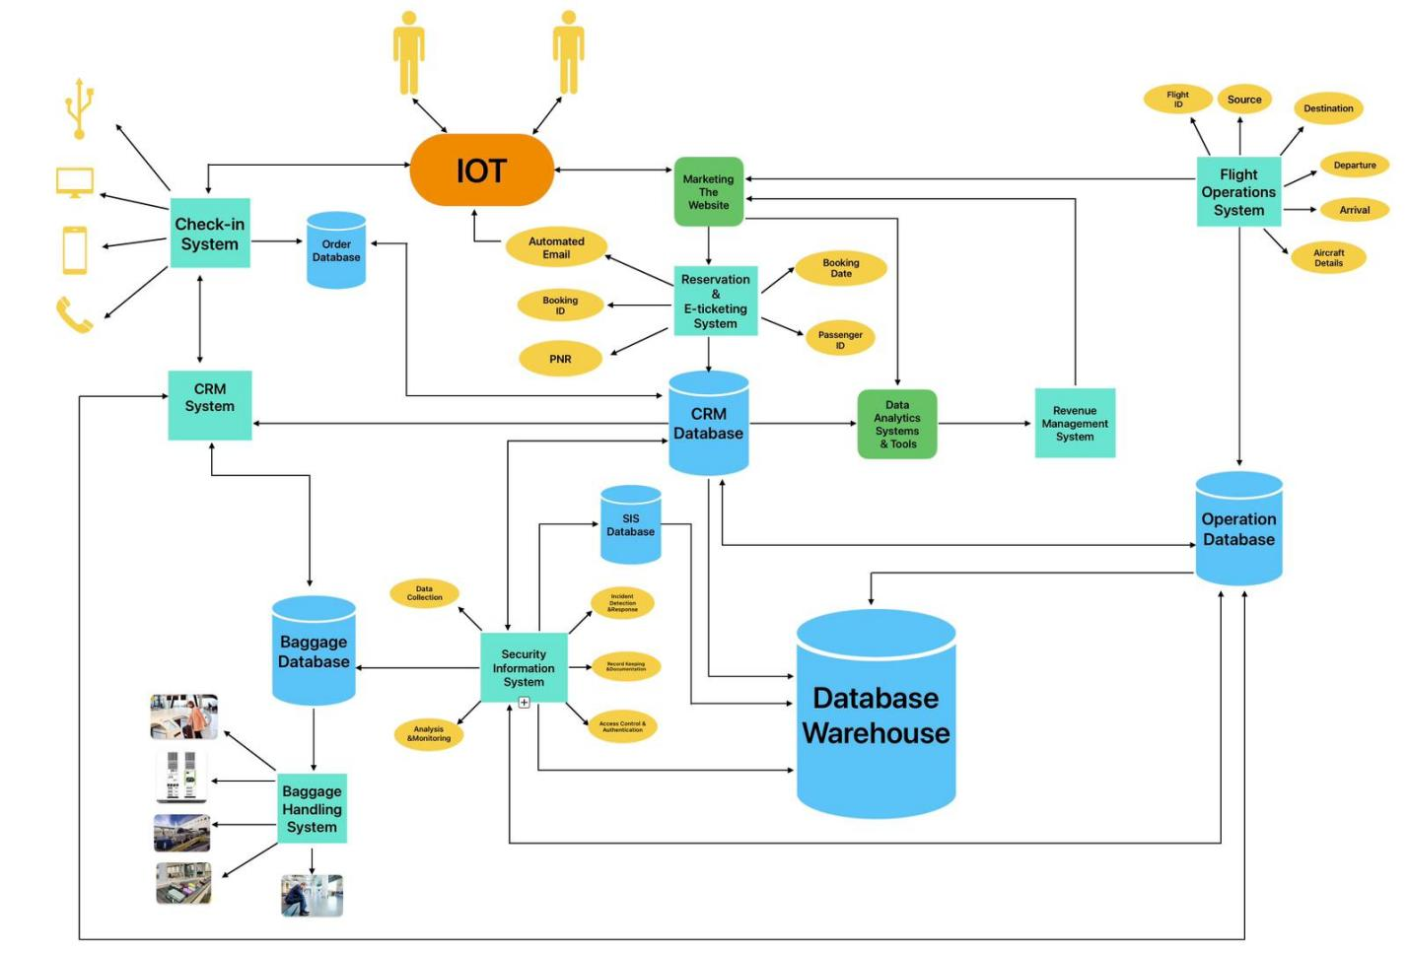
1.1 Internet of things
In the present interconnected world, individuals enjoy the ease of accessing a wide range of information and services through the Internet of Things (IoT). This mutually linked system allows for the creation of personalized cloud-based accounts and grants access to numerous online platforms catering to their specific requirements. The objective of this group paper is to spotlight users who seek to book flights for their travelling needs.
As the hypothetical user sets out to book a flight, they will start their online search on a search engine to find the most suitable options based on their individual travel preferences. The airline industry is highly competitive, and attracting potential customers involves a multifaceted approach led by the marketing team of the airline.

1.2 Registration Process in Websites through Marketing
Upon clicking the airline's website, the user is urged to create a personal account. This is crucial to initiate flight searches and bookings. During the registration process, the user must furnish personal details, such as their name, contact information, and any frequent flyer or loyalty program particulars they possess. The airline's database securely saves this information, safeguarding the user's sensitive data.
The user is requested to settle their payment and choose their preferred flight, seat, and additional services including baggage options, to continue with the booking process. Following payment, the airline's reservation and e-ticketing system (Qteishat, M.K., Alshibly, H.H., 2014) will take over. This system produces a complete e-ticket comprising vital information about the user's flight, such as the travel plan, seat allocation, take-off and landing timings, and any exceptional directives or services requested during the flight.
Simultaneously, an automated email is dispatched to the user's registered email address, providing them with an electronic version of their e-ticket and all essential flight particulars. This correspondence serves as verification of the reservation and a helpful point of reference for the user's travel arrangements.

1.3 Customer Relationship Management (CRM)
All user information is transferred to the airline's Customer Relationship Management (CRM) system, due to globalization, increasing competition, market saturation and rapid advances in technology. The aim of CRM is to understand the profitability of their customers and to retain the profitable ones. Therefore, many firms need to be able to determine the value of their customers to retain or even cultivate the potential profit of customers (Liou, J.J.H., 2009). Along with booking details. This database contains a treasure trove of customer data. It helps the airline gain valuable insights into the preferences and behavior of its clientele. The CRM system also enables the airline to engage in personalized marketing. This can include targeted email campaigns and loyalty program offers.
The data is also fed into advanced analytic tools that crunch numbers and analyze trends to gain a deeper understanding of customer behavior and booking patterns. This wealth of information is invaluable to the marketing team, helping them to create more effective marketing strategies, tailor promotional offers and optimize the airline's overall business operations.
Data is also fed into a revenue management system that plays a key role in pricing strategies, in addition to CRM and analytic. This system uses dynamic pricing algorithms to adjust fares in real time. This maximizes revenue while ensuring that flights remain competitive in the market. The marketing team relies on this data-driven pricing information to remain agile in a volatile market. Helping to ensure that the airline remains cost effective and profitable.
The entire process of booking a flight on an airline's website involves the seamless integration of multiple systems and strategies. The tip of the iceberg is the user journey from initial search to booking. Behind the scenes, to meet user needs, understand their behavior, fine-tune marketing efforts, manage costs and drive business development, a web of interconnected systems including SEO, Google Ads, CRM, analytics and revenue management work in unison. It is this intricate dance of technology and data analytics that is driving the airline industry forward in the digital age, ensuring that customers can find the flights they need and that airlines can remain competitive in an ever-evolving marketplace.

2.1 Customer Service
Nowadays, Airports are under increasing pressure to provide excellent customer service while managing complex operations to ensure passenger satisfaction and overall airport efficiency. To meet these challenges and achieve organizational goals, a well-implemented DBMS, coupled with integrated ICT solutions, can streamline operations, improve communication, and elevate the passenger experience.

2.2 Customer Service Objectives
However, Airports play a vital role in the travel experience, and optimizing customer service is essential to achieving organizational goals. So, what are the organizational objectives of the customer service department in the airport industry? The department's objectives are often aligned with the wider objectives of the aviation organization. Firstly, streamline check-in, boarding, and other customer service processes to reduce waiting times and improve overall operational efficiency. Secondly, to provide passengers with clear and accurate information about flight status, gate changes, baggage policies, and other relevant details. Third, ensure the safety and security of passengers and their belongings by complying with all relevant safety and security protocols and regulations in addition, ensure on-time departures and arrivals by managing the boarding process and effectively resolving any delays or disruptions. Finally, to enhance passenger satisfaction and loyalty by providing excellent customer service and meeting passenger needs in a timely and courteous manner.

2.3.1 Check-in
The key components and data of a dedicated order database for customer service departments in the airport industry include order or booking information, baggage check-in and tracking information, and passenger check-in details (including online check-in). This database is critical for airlines, airports, and air service providers to ensure smooth customer interactions and operational efficiency. The CRM system allows for the collection and storage of comprehensive passenger data. Integrate different ICT solutions with the order database to enhance check-in services. Firstly, self-service terminals at airports can access the order database, retrieve passenger booking information, and allow passengers to check in for their flights. Passengers can print boarding passes, select seats, and update information. Secondly, integration with the order database allows passengers to check-in online before arrival at the airport. Passengers can select seats, update contact information, and make special service requests. The online check-in data is synchronized with the order database to ensure real-time updates. Once again, the mobile application accesses the order database, providing passengers with a convenient way to check in using their smartphones. Passengers can receive mobile boarding passes and notifications. Finally, orders can be booked by calling directly through the customer service hotline provided by the airline.

2.3.2 Baggage Handling
The airport customer service department's baggage database manages and tracks passenger check-in baggage, which ensures that the baggage is transported accurately, loaded onto the correct flight, and delivered to the passenger at the destination. When a passenger boards a plane at the airport, his or her checked-in baggage is tagged with a unique identifier, such as a barcode or RFID tag. This includes the passenger's name, flight details, and a unique baggage identifier. The baggage handling system records this identifier to link the baggage to the passenger's flight booking and destination. In addition to this, the baggage database cross-references the baggage tag with the passenger's flight details and loads the baggage onto the appropriate aircraft based on the flight details stored in the database. Once the passenger arrives at the destination, the baggage is unloaded from the aircraft and scanned. The database is updated to reflect the arrival of the baggage, and a notification is generated to inform airport staff that the baggage is ready for acceptance. The database continues to track the baggage until it is claimed. The baggage database also plays a significant role in security and compliance. It tracks the screening status of baggage to ensure that it has undergone a security check, which is essential for safety. The Customer Service Department uses the database to assist passengers in claiming lost, delayed, or damaged baggage. They can check baggage details and provide status updates to passengers.

2.3.3 Security
The Security Information System (SIS) database of the Airport Customer Service Department ensures that security data on passengers, staff, and airport facilities is collected from a variety of sources, such as surveillance cameras, access control systems, sensors, alarms, biometric devices, and security personnel reports. These data are integrated into a central SIS database, which serves as a repository for all security-related information. The SIS database is monitored in real-time by security personnel in the customer service department, which constantly monitors a variety of security data sources. This includes monitoring surveillance camera inputs, access logs, sensor data, and incident reports. The SIS continuously analyzes the data to identify potential security threats. This may include pattern recognition, anomaly detection, and real-time event monitoring. Security personnel monitor the consolidated data in a centralized control room where they can access information in real time and react to threats as they arise. When the SIS identifies a security threat or event, it issues alerts. Security personnel can quickly access relevant information about the incident, such as video footage, logs, and sensor data, to assess the situation. All security-related data, including incident reports, video footage, and access logs, is stored and archived for compliance and investigative purposes, and the SIS can also be used to manage access control, ensuring that only authorized personnel have access to secure areas of the airport.

Conclusion
Following the introduction of the specific utilization of DBMS and ICT infrastructure, the strengths and limitations are discussed in this section.
It is unambiguous that DBSM is advantageous. The first is data sharing, or the usage of data across various divisions simultaneously. The operational database contains customer reservation information that the marketing department can access for user preference analysis. Second, data transmission is efficient. Global baggage data repository allows airlines and airport systems to get end-to-end information in real-time. For example, baggage tracking is a frequent application scenario in which tags are attached to pieces of baggage then the boarding badge presents a location for picking up bags upon arrival. If luggage is lost, it will be tracked through the monitoring system, and it is reported to ground workers and the airline simultaneously. Third, the database's storage capacity, when it exists on the cloud, could be a vast room of space for holding data. Whether it's an order database, luggage database, reservation database, or marketing database, all data is transmitted to the main database which stores the travel history and also allows us to output the reports and data for depth analysis.
In the end, this research focuses on leveraging DBMS and ICT solutions in the execution of order, baggage, SIS, CRM, and operational databases for a fictitious airline and airport. By presenting the diagram to demonstrate each database model can be connected and integrated together, a fast and dependable data delivery between different business departments, and companies, would be able to deliver the optimal experience for passengers. Finally, since this study may not be adequate, we discussed the advantages and drawbacks of the whole suggested DBMS infrastructure. The advantages when utilizing it included data sharing, quick data transmission, and a large storage capacity. The drawbacks would be supplier lock-in, pursuing talent but incurring additional costs, and SIS's concerns about cyber-attacks.

Reference List
Liou, J.J.H. (2009). A novel decision rules approach for customer relationship management of the airline market. Expert Systems with Applications, 36(3), pp.4374–4381.
Qteishat, M.K., Alshibly, H.H. and Al-ma’aitah, M.A. (2014). The impact of e-ticketing technique on customer satisfaction: an empirical analysis. Journal of Information Systems and Technology Management, 11(3).
K.I., Tselikas, N.D. and Nasiopoulos, D.K. (2022). Airlines’ Sustainability Study Based on Search Engine Optimization Techniques and Technologies. Sustainability, [online] 14(18), p.11225.
Mohd Selamat, S.A., Prakoonwit, S., Sahandi, R., Khan, W. and Ramachandran, M. (2018). Big data analytics-A review of data-mining models for small and medium enterprises in the transportation sector. Wiley Interdisciplinary Reviews: Data Mining and Knowledge Discovery, 8(3), p.e1238. doi:https://doi.org/10.1002/widm.1238.

